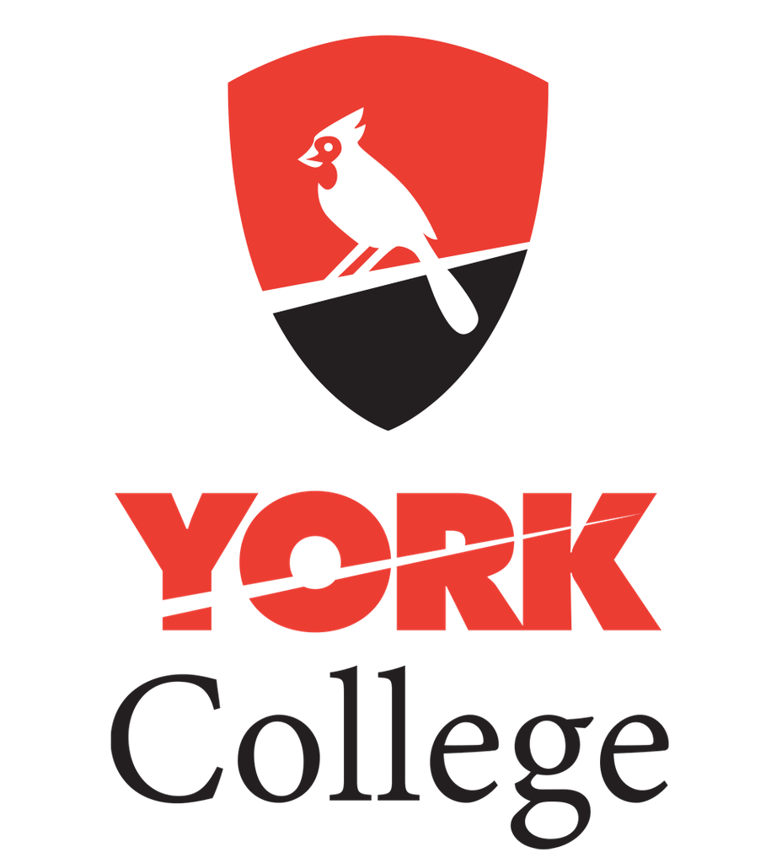

**On-site Visit**

-------------------------------------

College

-------------------------------------

**December 3rd, 2019**

**9:30 A.m.**

Outside B Building

* 3.5 gpa Required
* 20:1 sTUDENT-teacher RATIO
* approx. 8,000 undergraduate students
* Athletic teams: Basketball, soccer, baseball, track & Field, tennis, cheerleading, volleyball, & more!
* 55+ mAJORs: business, journalism, computer science, physician assistant, education, nursing, occupational therapy & More!

“York College enriches lives and enables students to grow as passionate, engaged learners with the confidence to realize their intellectual and human potential as individuals and global citizens.”